File Directory

File Name ：File Directory
File No. ：
Version No.：V1.0

Total 6 pages
(Including cover)

Compose dongqiwu
Review
Countersign

CILICO Microelectronics Ltd
Modify the record
File No. | Version No. | Composed By / Modified By | Compose / Modify Date | Modify Reason | Major change（Write the main Points） | Review By
 | V1.0 | Dong qiwu | 2017.03.15 | null | null | Shiliangyi
Note: When the file is prepared for the first time, write “None” on "Modify Reason" and "Major modifications columns

Contents
1 Introduction 4
2 Applicable scope 4
3 Content 4
4 Secondary development steps 5

1 Introduction
Describe the role of each directory, and which documents are included, so that users can access the relevant information.

2 Applicable scope

Hardware includes PSAM head functions

3 Content
3.1 PSAM Manual
File path :“\ PSAM\UserMenu\”， Which contains two documents in English and Chinese, the document details the basic functions of the sample program.
3.2 API Interface specification file
File path: “\ PSAM\APIDocument\”， which contains two documents in Chinese and English, by learning this document, you can quickly docking to complete the secondary development.
3.3 App Installation file
File path: “\ PSAM\Apk\”。
3.4 Source code
File path: “\ PSAM\SourceCode\”。

4 Secondary development step
4.11 Load libhardware-print.so
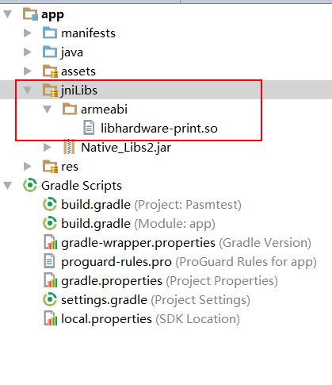
4.12 Modify the build.gradle file, the code is configured as follows:
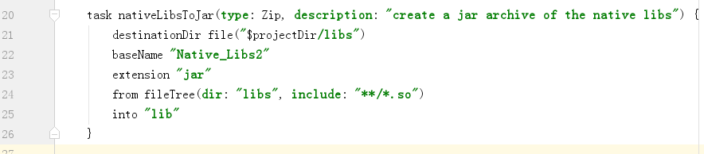

4.12引入hardware\rfid\sam.java

